**介绍某个好去处**

**写作任务 (Section B 3c)**

假如你在某贴吧看到一个英国朋友Kim的求助帖。他提到假期要来你市旅游。根据行程安排，他想去当地一家影院观影，也想去一家有特色的餐馆就餐。请你选择其中一项，给他回帖推荐。

**●【审清题目】**

**内容：**推荐一家影院或一个餐馆，要着重从几个方面介绍为什么它是最好的。

**文体：**介绍某处地方，属于说明文。

**时态：**用一般现在时。

**人称：**介绍某处地方，可用第三人称。

**●【头脑风暴】**

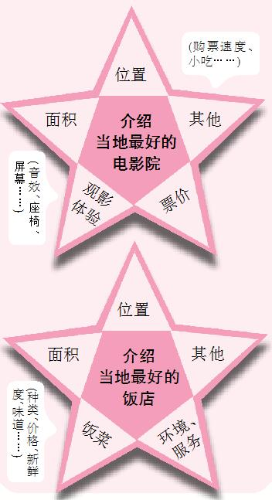

**●【提供素材】**

**◆短语**根据汉语提示，写出对应的英文表达。

|  |  |
| --- | --- |
| **The best place in my**  **town** | **Why?** |
| ... Cinema | (1)_______________(离我家最近的), the best sound, the most comfortable seats, (2) _______________(最大的屏幕), the most popular, the shortest waiting time, buy tickets the most quickly, (3)_______________(最便宜的票), the most delicious popcorn (爆米花) |
| ... Restaurant | the biggest  / largest restaurant, the most kinds of dishes (菜肴), (4)_______________(最新鲜的食物), the lowest (最低的) prices, (5)_______________(最美味的汤), the best  / most comfortable environment (环境), (6)_______________(最好的服务), the friendliest / nicest waiters (服务员), the most enjoyable, taste the best  / have the best taste, the most famous (著名的), play the most wonderful music |

**Key:**1. the closest to my home   2. the biggest screens  3. the cheapest tickets

4. the freshest food  5. the most delicious soup   6. the best service

**●【谋篇布局】**将括号内的汉语翻译成英语，补全短文。

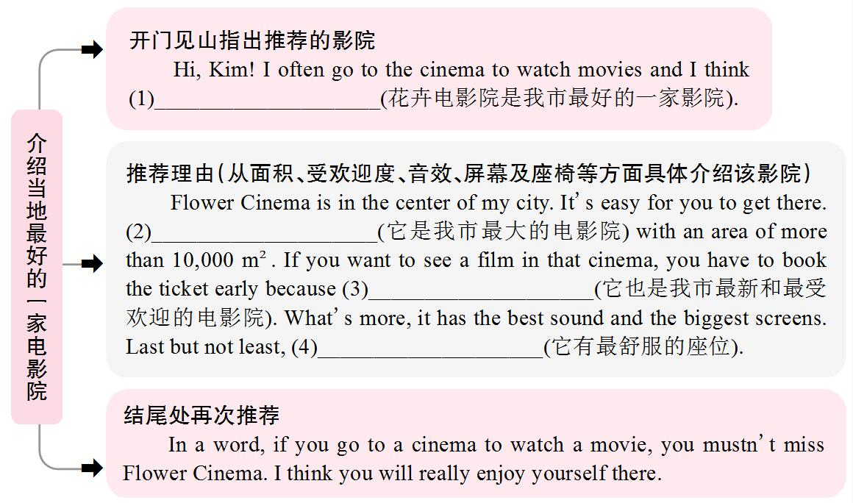

**Key:**1. Flower Cinema is the best one in my city

2. It's the largest cinema in my city

3. it's also the newest and the most popular cinema in my city  4. it has the most comfortable seats

**◆句型**

1. ... has the best ...

2. ... is the best because ...

3. ... is better than ..., but ... is the most ...

4. I think ... is better than any other ...

5. It's the most ... near here / in my city.

6. It has an area (面积) of ...

7. It has some specials every day.

8. The best place to eat / relax ... is ... Restaurant / Cinema.

9. The food is delicious and not expensive.

10. It's necessary to book (预订) a table online early because it's the most popular restaurant in town.

11. If you want to see a film / enjoy your dinner, you can go to ... Cinema / Restaurant.